CLIENT REQUIREMENTS

Social Media Automation
& Fanvue Integration
Phase 2: Automatic Posting | Phase 3: Fanvue & Monetisation
Purpose: collect the decisions, account access, hosting details and content inputs needed to implement social media automation. Please fill in the “Client response” column where applicable.
Priority key: START = required to begin setup • GO-LIVE = required before launch • LATER = can be deferred

4. Phase 2 requirements — automatic posting

A. Decisions and scope
ID | What we need | Why it matters | When | Client response
A1 | Confirm the Phase 2 scope and platform order. Suggested order: Instagram → TikTok → X. | Each platform is implemented and tested separately; the order determines what goes live first. | START | It will just be Instagram and Tiktok
A2 | Choose TikTok mode:  • Inbox mode: send each video to TikTok drafts; the client taps Publish in the app.  • Direct mode: fully automatic posting, subject to TikTok app review and approval. | Inbox mode is the practical starting point. Until the required approval is granted, API posts may be restricted to private visibility. | START | Inbox mode to start with then look to go fully automated in due course.
A3 | Confirm engagement scope. Suggested starting point: post statistics and AI-drafted comment replies for client approval. Confirm whether automatic replies or DMs are also expected. | Platforms restrict automated messaging and some use cases. Only permitted and authorised features will be implemented. | GO-LIVE | As much automation as possible but where not possible, push notifications to me on the apps, so I know there’s messages/decisions that are required.
A4 | Confirm posts per day for each platform, preferred posting times and time zone. Initial target mentioned: at least one post per day. | Sets scheduling defaults and daily limits. | GO-LIVE | 10 posts per week on each platform; random times, at least one per day; 3 x days with 2 posts.  Use the same 10 posts on each platform each week.
A5 | List who needs dashboard access and who will approve posts. Include names and email addresses. | The current dashboard uses one shared login; additional users may be needed. | GO-LIVE | Just me for now.
A6 | Confirm acceptance of platform rules for AI-generated content and required labels/disclosures. | Incorrect or missing disclosures may lead to content or account restrictions. The available controls differ by platform. | GO-LIVE | Yes.

B. Hosting and availability
ID | What we need | Why it matters | When | Client response
B1 | Provide a small Linux VPS, suggested baseline 2 GB RAM, with disk capacity appropriate for the media library. Confirm approximate file count and total media size. The client can provision it or the developer can help set it up; hosting is paid by the client at cost. | The application and scheduler need to run continuously, and platforms may need to fetch media from a publicly reachable location. | START | Please make a suggestion on what cloud server to use and then I’ll go about setting it up.
B2 | Provide a domain or subdomain controlled by the client (for example, studio.yourdomain.com) and access to whoever can update DNS. HTTPS will be configured. | A secure public address is generally needed for OAuth callbacks and media delivery; exact requirements depend on the platform integration. | START | As above, let me know what domain host to use and I’ll set it up.
B3 | Approve automatic daily backups of the database and media. | Protects drafts, settings and the media library. | GO-LIVE | As above.

C. Instagram — @summerh_03
(Creator Account)
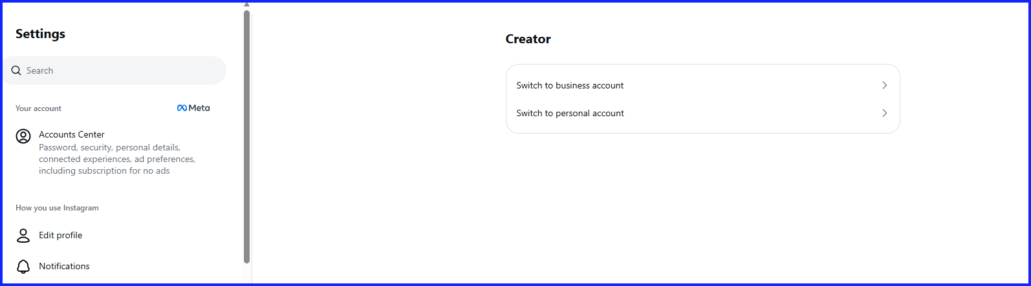
ID | What we need | Why it matters | When | Client response
C1 | Switch Instagram to a professional account (Business or Creator). | Professional account access is generally required for supported automatic publishing workflows. | START | I think it is already professional/creator account.
C2 | Create a Meta developer account and app with guidance, then add the Instagram account as a tester if applicable. | The app and account must be configured for the required permissions. Whether app review is needed will be confirmed during setup. | START | Tried this but it failed as my ID was not verified – may need help with this?
C3 | Provide the Meta app ID and app secret through a secure method. | Required to configure the integration and request permitted access. | GO-LIVE | As above
C4 | Join a short setup session and sign in personally to authorise the connection. We will confirm whether a linked Facebook Page is required for the chosen integration. | Authorises access without sharing the account password. | GO-LIVE | Noted.

Implementation note: Posting limits and token lifetimes can change. The integration will follow the current platform documentation and refresh tokens where supported.

D. TikTok — @its_me_summerh
ID | What we need | Why it matters | When | Client response
D1 | Register for TikTok for Developers, create an app and enable the Content Posting API, with guidance. | Required for API-based publishing. | START | Will get this done.
D2 | Verify the configured web address in the TikTok developer portal and add the required redirect settings. | Needed for supported sign-in and media workflows. | GO-LIVE | Need advice on this.
D3 | Provide the app client key and secret through a secure method. | Required to configure the integration. | GO-LIVE | Need advice on this.
D4 | For direct-publication mode only, agree to submit the app for TikTok review. The developer can prepare supporting demo materials and answers. | Direct public posting may require review and approval. Approval and timing are controlled by TikTok. | LATER | Ok.

Implementation note: TikTok capabilities vary by API approval and product access. Comment replies may need to remain manual in the TikTok app.

E. X (Twitter)
ID | What we need | Why it matters | When | Client response
E1 | Create or confirm Summer’s X account. If creation is blocked, share the error or verification step so we can help troubleshoot. | An active account is required before posting can be configured. | START | Struggling with X setup.
E2 | Create an X developer account and app with guidance; provide the app credentials securely. | Required for API-based posting. | GO-LIVE | as above
E3 | Set up prepaid API access if required by the chosen plan, establish a monthly spending cap and confirm the budget. | Posting can fail if the API plan or available credits do not cover the request. Current pricing must be checked before launch. | GO-LIVE | as above
E4 | Confirm whether X posts should omit links by default to control costs. | Link-related API pricing may differ by plan and endpoint; verify current pricing before implementing this rule. | GO-LIVE | As above

F. Content, AI and media
ID | What we need | Why it matters | When | Client response
F1 | Provide the Halloween and general images/videos as accessible files: for example, a locally synced Dropbox folder, a downloaded folder or suitable shared access. Confirm approximate file count and total size. | The system needs the actual media files to inspect content and publish them. Broken or empty uploads will be excluded. | START | All available in dropbox
F2 | Provide a funded AI API key for Claude and/or Mistral, with a monthly spending limit. A Claude.ai subscription does not itself provide API credits. | A funded API key is needed for reliable generation. Claude connectivity must be tested with the supplied key before it is relied on in production. | GO-LIVE | Will need advice on how to do this
F3 | Share notes on the six reference Instagram accounts using docs/REFERENCE_RESEARCH.md: hook styles, caption length, emoji use, CTAs and posting cadence. | The client’s observations will inform Summer’s style; the system will not depend on scraping the reference accounts. | LATER | What is required exactly with this?
F4 | Review Summer’s persona in the Profiles page. Confirm any changes, topics to avoid and preferred CTA wording. | The voice should be validated before content is published automatically. | GO-LIVE | Need to establish a good source for the voice – I’m generating most images in Higgsfield, can we get the voice from there too?
F5 | Confirm the current link in Summer’s bio and the intended destination. | Calls to action and external links must comply with the applicable platform rules. | GO-LIVE | Link is not on the page yet.

5. Phase 3 requirements — Fanvue and monetisation
Discovery note: Fanvue has a developer portal with sign-in (OAuth), but the available API features (such as posts, messages, insights and subscriber data) and rules for AI creators and automated messaging must be verified against Fanvue’s current official documentation and terms before any feature is promised. The source material proposes a short 1–2 day discovery step after access is available.
ID | What we need | Why it matters | When | Client response
H1 | Ensure the Fanvue account @its_me_summer is active and the account owner has completed any required identity verification (KYC). | The source notes that creator verification may be required to create developer apps; confirm the current requirement with Fanvue. | START | It’s live and I’ve scheduled posts throughout October to build a library.
H2 | Create a Fanvue developer app with guidance, provide the client ID and secret securely, and have the account owner sign in to authorise access. | Required to investigate and configure any supported Fanvue connection. | GO-LIVE | Need advice on this.

Document scope note: This document reorganises the requirements present in the supplied source text. The supplied text ended at Phase 3 item H2; no additional Phase 3 requirements have been inferred or added.

